|  |  |  |  |
| --- | --- | --- | --- |
| **From Branch to Corporate Office** | **Time of Travel (Round Trip)** | **Distance of Travel**  **(Round Trip)** | **Cost of Travel**  **(55¢ Per Mile)** |
| Frankston Branch | 18 Minutes | 31.4 Miles | $17.27 |
| Troup Branch | 40 Minutes | 35.2 Miles | $19.36 |
| Bullard Branch | 32 Minutes | 26 Miles | $14.30 |
| 5 Longview Branches | 2 Hours 28 Minutes  (12 hours 20 Minutes Total) | 132 Miles  (660 Miles Total) | $72.60  ($363 Total) |
| 5 Tyler Branches | 1 Hour 10 Minutes  (5 hours 50 Minutes Total) | 54.4 Miles  (272 Miles Total) | $29.92  ($149.60 Total) |
| 2 Marshal Branches | 2 Hours 38 Minutes  (5 Hours 16 Minutes Total) | 144.6 Miles  (289.2 Miles Total) | $79.53  ($159.06 Total) |
| Gilmer Branch | 2 Hours 40 Minutes | 131 Miles | $72.05 |
| Total for each meeting | 27 Hours 36 Minutes | 1,444 Miles | $794.64 |
| Total for year with monthly Branch Manager meetings | 13 Days 9 Hours 12 Minutes | 17,328 Miles | $9535.68 |

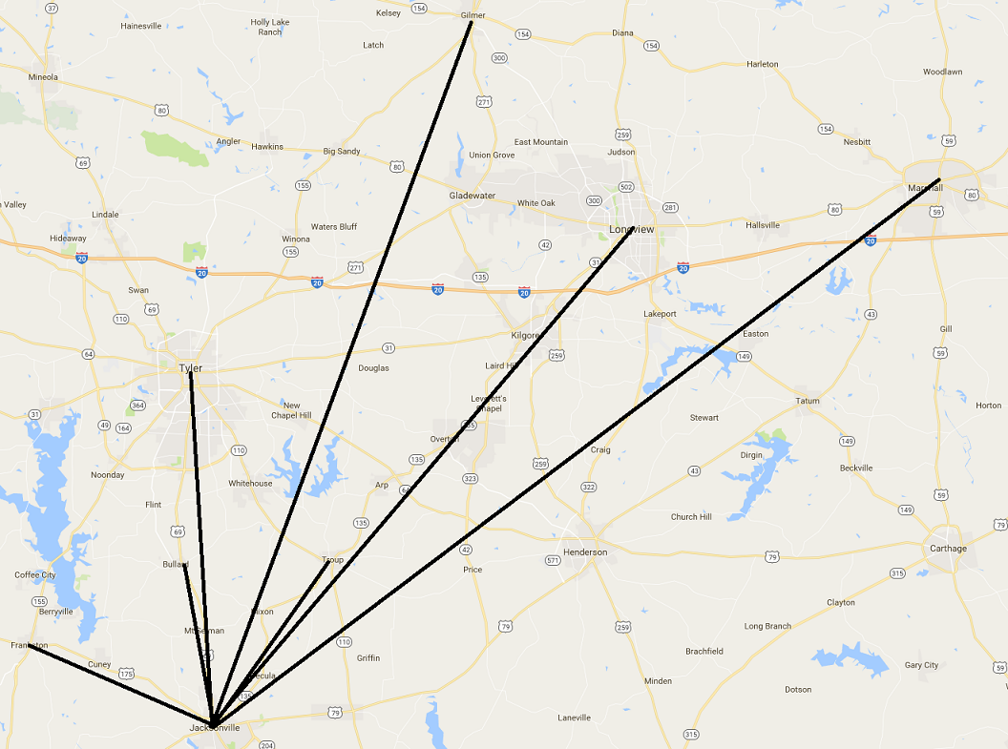

Regional banks are utilizing OmniJoin Private Cloud to have secure meetings that saves time and money.

This is a regional bank with 15 branches throughout East Texas. This bank has monthly branch manager meetings at the corporate office. All Branches are within 1 hour and 30 minutes of the corporate office in Jacksonville, TX.